1. Introduction
Choosing a suitable career can be difficult for students, especially when they are unsure about how their skills, interests, and preferred way of working relate to different career areas. Students may have several abilities and interests but may not know which career areas are more suitable for them. Traditional career guidance may also require support from teachers, career advisors, or other professionals.
To address this problem, this project develops a Career Guidance Expert System, which is a rule-based expert system designed to provide career recommendations based on a student's skills, interests, and work preferences. The system collects information from the student and represents the selected information as facts. These facts are then evaluated using a set of predefined career-related rules.
The system uses SWI-Prolog as the expert system engine and applies rule-based reasoning to identify suitable career areas. The system also provides explanations of how recommendations are produced, allowing the user to understand the reasoning behind the results.
The developed system covers eight career areas: Software Development, Data Analysis, Cybersecurity, Network Engineering, UI/UX Design, Business Analysis, Accounting & Finance, and Digital Marketing. The system is intended to support students in exploring possible career areas based on their own characteristics rather than providing a guaranteed career choice.
The project also demonstrates important expert system concepts such as knowledge representation, facts and rules, forward chaining, backward chaining, and explainable reasoning through a web-based user interface.

2. Selected Domain
2.1 Domain Selection
The selected domain for this project is Career Guidance. The system focuses on helping students explore career areas that may match their skills, interests, and work preferences.
Career guidance was selected because students may have different combinations of technical skills, personal interests, and preferred working styles. For example, a student who enjoys programming and problem-solving may be interested in software development, while a student who enjoys mathematics, analyzing information, and working with data may be interested in data analysis.
The selected domain is suitable for an expert system because career-related knowledge can be represented using facts and rules. The system can compare a student's characteristics with documented characteristics of different occupations and use this knowledge to produce explainable recommendations.
2.2 Career Areas Covered
No. | Career Area | General Focus
1 | Software Development | Programming and software development
2 | Data Analysis | Analysing data and identifying useful information
3 | Cybersecurity | Protecting systems, networks, and information
4 | Network Engineering | Managing and troubleshooting computer networks
5 | UI/UX Design | Designing user interfaces and user experiences
6 | Business Analysis | Analysing business needs and information
7 | Accounting & Finance | Financial information, accounting, and detailed analysis
8 | Digital Marketing | Marketing, communication, creativity, and audience engagement

3. Problem Definition
Students often find it difficult to determine which career areas are suitable for their abilities and interests. Having a particular skill does not always clearly indicate which career area a student should explore, as career suitability can depend on a combination of skills, interests, and preferred working styles.
The problem addressed by this project is therefore the lack of a simple rule-based system that can combine these different characteristics and provide understandable career recommendations.
The proposed Career Guidance Expert System addresses this problem by collecting information about the student's skills, interests, and work preferences. These inputs are converted into facts and evaluated against predefined rules in the knowledge base. When the required conditions of a rule are satisfied, the corresponding career area is recommended.
The system also provides reasoning information so that the student can understand which rules and characteristics contributed to a recommendation. However, the system is designed as a career exploration and guidance tool, and its recommendations do not guarantee that a particular career will be successful or suitable for every individual.

4. Objectives
4.1 Main Objective
The main objective of this project is to develop a rule-based Career Guidance Expert System that recommends suitable career areas based on a student's skills, interests, and work preferences using knowledge-based reasoning.
4.2 Specific Objectives
- To identify and represent career-related knowledge using facts and rules.
- To develop a knowledge base containing career-related facts and at least 20 rules.
- To implement rule-based inference using SWI-Prolog.
- To demonstrate forward chaining for deriving career recommendations from the student's selected facts.
- To demonstrate backward chaining for reasoning from a potential career recommendation back to the required conditions.
- To provide explainable recommendations by showing the reasoning and rules related to the recommended career areas.
- To develop a user-friendly web interface through which students can enter their skills, interests, and work preferences.
- To test the expert system using different combinations of user inputs and verify whether the expected career recommendations are produced.

2. System Explanation
The Career Guidance Expert System is developed to recommend suitable career areas by analyzing three main types of information provided by the student: skills, interests, and work preferences. The system follows a rule-based reasoning approach, where the student's selections are compared with predefined career rules.
First, the student interacts with the React-based web interface and selects the skills, interests, and work preferences that best describe them. These selections are stored as facts, such as programming skill, technology interest, or problem-solving skill.
The selected facts are then sent to the Node.js backend through an API. The backend acts as the connection between the web interface and the Prolog expert system. It passes the selected facts to the SWI-Prolog program for reasoning.
The Prolog system contains the knowledge base, which consists of career-related facts and rules. The rules define combinations of conditions that can lead to a particular career recommendation. For example, a combination of programming skill, problem-solving skill, and technology interest can satisfy a rule for Software Development.
The inference engine checks the user's facts against these rules. The system uses forward chaining to derive career recommendations from the available facts. Backward chaining is also implemented to determine whether the conditions required for a particular career recommendation can be satisfied.
Once the relevant rules are satisfied, the system generates one or more career recommendations. The recommendations are sent back through the backend and displayed on the web interface. The system also identifies the rules that contributed to the recommendation, allowing the user to see why a particular career area was suggested.
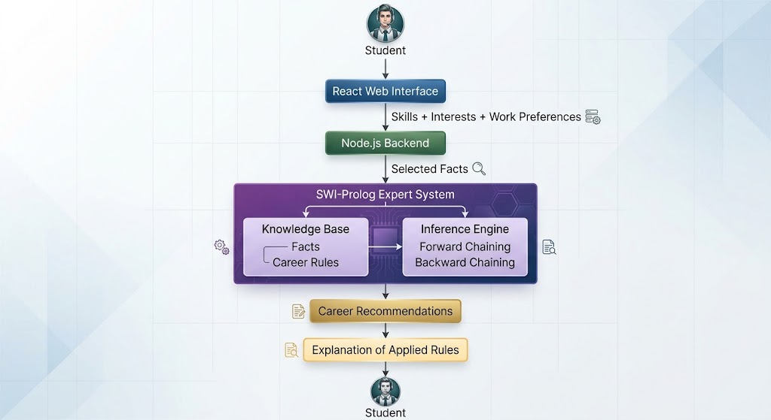

3. User Interface
The Career Guidance Expert System provides a web-based user interface that allows students to complete the assessment step by step. The interface is designed to make the process simple and easy to understand while collecting the information required by the expert system.
The assessment is divided into three main stages: Skills, Interests, and Work Preferences. After completing these stages, the selected information is passed to the rule-based expert system and the resulting career recommendations are displayed.

3.1 Home Page
The Home Page is the starting point of the system. It introduces the Career Guidance Expert System and provides a brief description of its purpose. The page explains that the system uses the student's skills, interests, and work preferences to identify relevant career areas.
A Start Career Assessment button allows the student to begin the assessment. The page also presents the assessment process in a simple sequence, showing how the student's information is transformed into career recommendations.
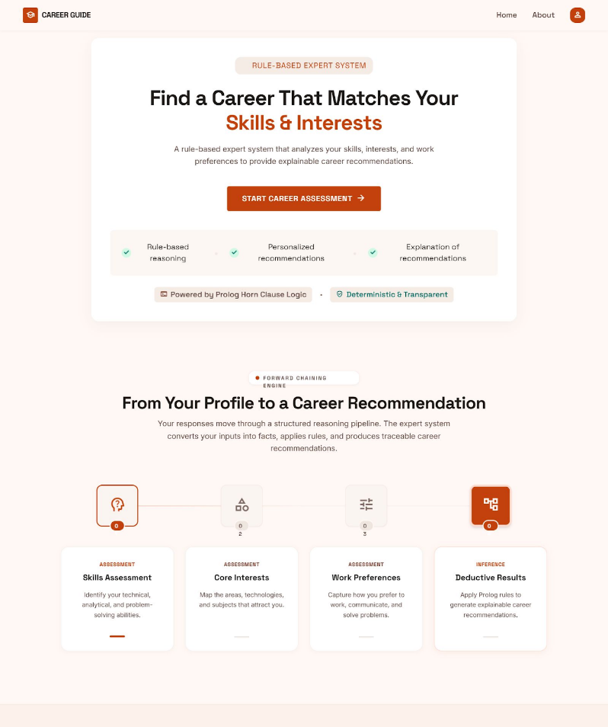

3.2 Skills Assessment Page
The Skills Assessment page collects information about the student's abilities. The student can select the skills that best represent their strengths.
The available skills include:
- Programming
- Mathematics
- Problem Solving
- Analytical Thinking
- Communication
- Creativity
- Logical Thinking
Each skill is presented as a selectable card. When a student selects a skill, the card changes its visual state to clearly indicate that it has been selected. The system also displays the number of selected skills.
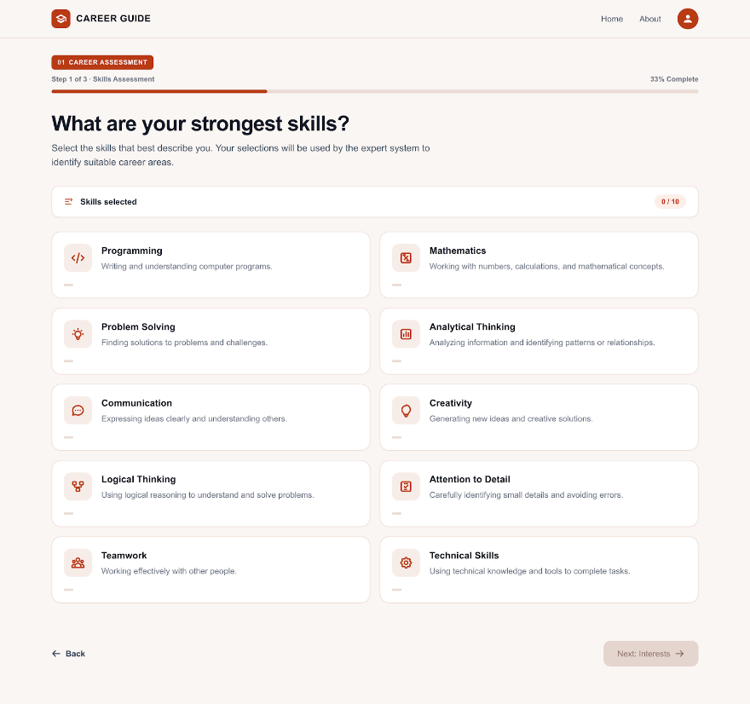
The student must select the required number of skills before proceeding to the next stage. The selected skills are stored and later converted into facts used by the Prolog expert system.

3.3 Interest Assessment Page
The Interest Assessment page collects the student's areas of interest. Students can select multiple areas that they are interested in developing as a career.
The available interests include areas such as:
- Technology
- Data
- Cybersecurity
- Networking
- Design
- Business
- Finance
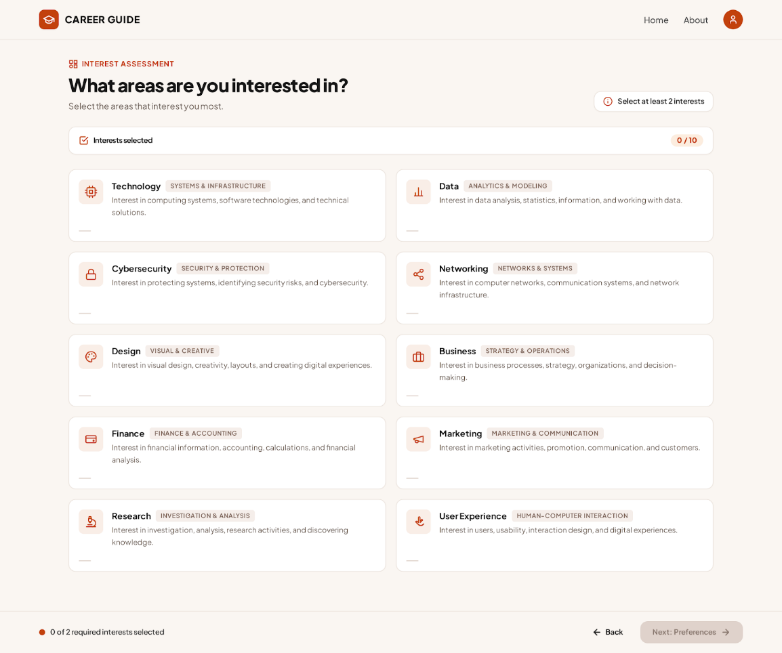
A minimum number of interests is required before the student can continue. The selected interests are stored as part of the student's assessment information and are later used as facts when evaluating the career rules.
3.4 Work Preferences Page
The Work Preferences page collects information about the student's preferred working style and activities. This provides additional information beyond technical skills and interests.
The available preferences include:
- Technical Problem Solving
- Data Work
- Creative Work
- People Interaction
- Computer Work
- Independent Work
- Teamwork
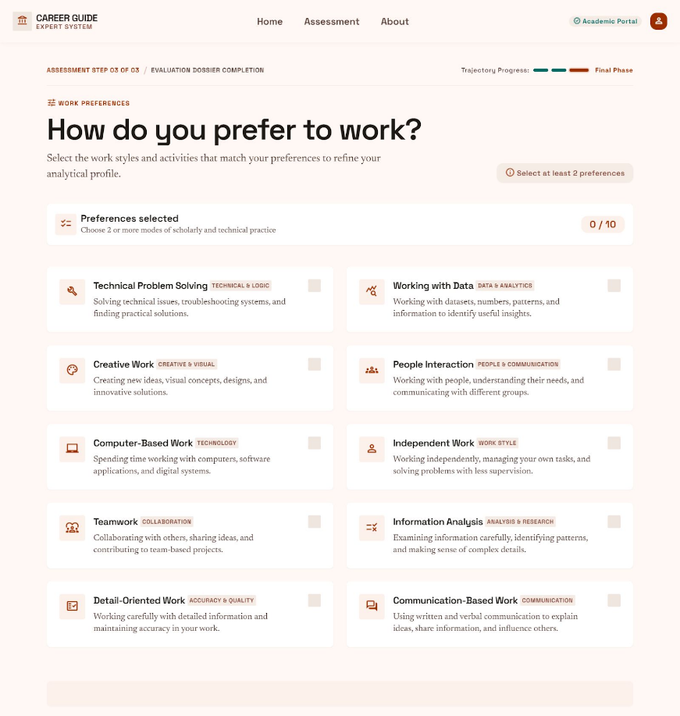
The student selects the preferences that best match their preferred working environment or activities. These selections are also converted into facts and passed to the expert system for rule evaluation.

3.5 Career Recommendations Page
After the student completes all three assessment stages, the system processes the selected information and displays the resulting career recommendations.
The page presents the matched career areas in a clear card-based format. The system can generate more than one recommendation when the student's selected facts satisfy rules associated with multiple career areas. The recommendation page therefore represents the output of the expert system rather than a manually selected career suggestion. The results are generated from the facts provided by the student and the rules stored in the Prolog knowledge base.
The system covers the following eight career areas:
- Software Development
- Data Analysis
- Cybersecurity
- Network Engineering
- UI/UX Design
- Business Analysis
- Accounting & Finance
- Digital Marketing
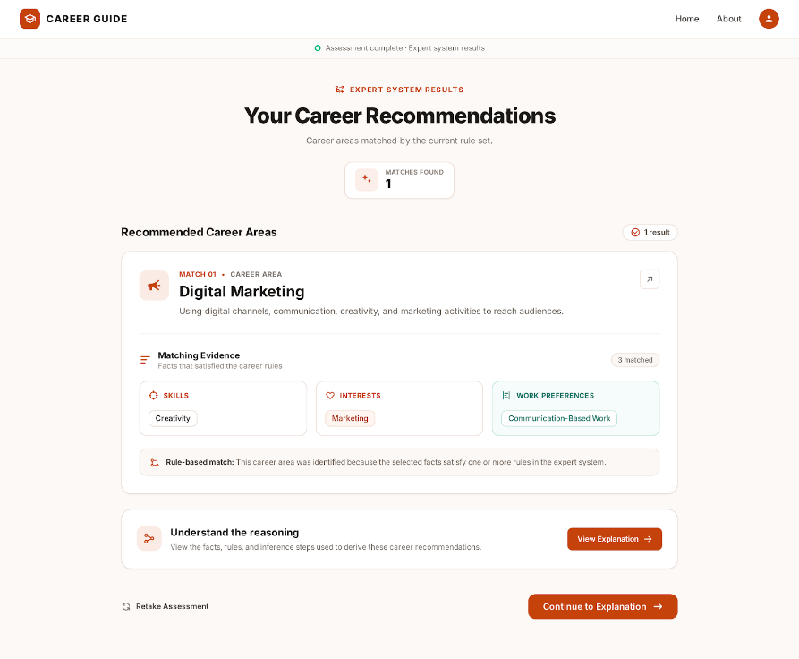

3.6 Explanation Page
The Explanation Page shows how the expert system arrived at the career recommendation. It provides the reasoning behind the result instead of displaying only the final career area.
The page presents the facts selected by the student, the rules satisfied by those facts, and the resulting career recommendation. This allows the student to understand the relationship between their assessment answers and the system's conclusion.
For example, if the student has selected programming skill, problem-solving skill, and technology interest, the system can show that these facts satisfy the corresponding Software Development rule. The explanation follows this sequence:
User Selections → Facts → Rules Applied → Reasoning → Career Recommendation
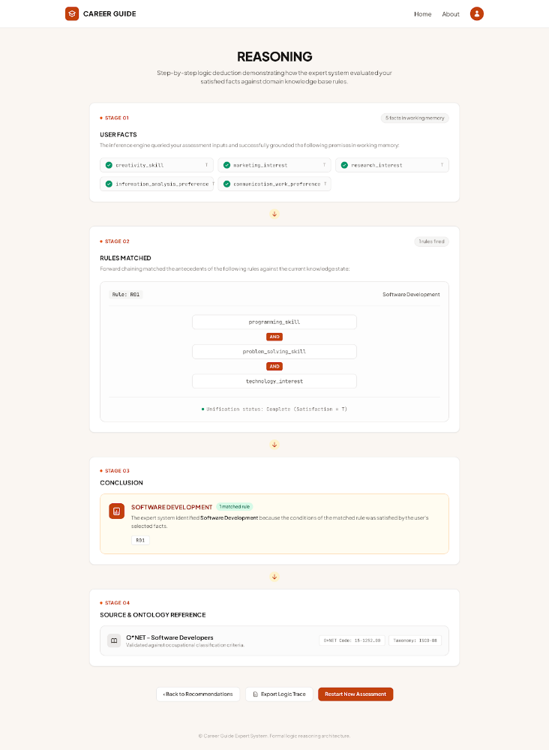
This feature makes the decision-making process of the expert system clear, traceable, and understandable to the user. It also satisfies the requirement of providing an explanation of how the system reached its conclusion.
About Page
The About Page provides an overview of the Career Guidance Expert System and its main components. It helps the user understand the technologies used to develop the system and the career areas covered by the expert system.
The page presents the main system technologies, including React + TypeScript for the user interface, SWI-Prolog for the rule-based expert system, and Forward and Backward Chaining for the inference process.
It also displays the eight career areas supported by the system: Software Development, Data Analysis, Cybersecurity, Network Engineering, UI/UX Design, Business Analysis, Accounting & Finance, and Digital Marketing.
The page provides navigation options to return to the Home Page or start the Career Assessment. This allows users to understand the system before beginning the assessment.


